**VIA ELECTRONIC SUBMISSION**

July 30, 2019

Food and Drug Administration

Division of Dockets Management

5630 Fishers Lane, Rm. 1061

Rockville, MD 20852

**Re: Docket No. FDA-2019-N-1845: Fixed-Quantity Unit-of-Use Blister Packaging for Certain Immediate-Release Opioid Analgesics for Treatment of Acute Pain; Establishment of a Public Docket; Request for Comments**

Dear Sir/Madam,

The United States Pharmacopeia (USP)[1] appreciates the opportunity to respond to the U.S. Food and Drug Administration’s (FDA’s) Request for Comments on *Fixed-Quantity Unit-of-Use Blister Packaging for Certain Immediate-Release Opioid Analgesics for Treatment of Acute Pain*.

USP is committed to supporting solutions to help mitigate the prescription opioid crisis.[2], [3] Over the last several years, USP has been using a multipronged approach to identify results-focused solutions for the opioid crisis. We have been convening, and collaborating with, stakeholders to consider approaches including development of up-to-date public quality standards, as well as other non-compendial strategies, to afford patients, families, caregivers, and healthcare professionals the mechanisms to protect against risks that these medications pose for misuse and abuse.

As part of this effort, we convened discussion forums and roundtables to seek input from representatives from federal agencies, healthcare organizations, and consumer-focused groups. Labeling, storage and disposal, and patient counseling were among the topics discussed. Outcomes from these discussions have encouraged USP to focus on principles to promote consistent auxiliary prescription warning labels for opioids, while examining how policy makers may advance uniform dispensing of prescription vials.

USP has also committed to better understand how packaging conditions may be used to mitigatee misuse and abuse as well as to promote appropriate and safe use of opioids. USP recognizes the widespread impact such work could have on regulatory policy, manufacturing, clinical practice, and patient access. As such, it is critical to consider all the potential impact, benefits, and risks of packaging configuration approaches on all stakeholders, including patients. These considerations should broadly encompass the entire supply chain and seek to identify intended, as well as unintended, outcomes that may result from such packaging modifications.

There are data to support that packaging configuration archetypes can help address various health and safety issues of medication use, including patient adherence, child exposure, third-party access, and excess supply. For example, calendar blister packaging can improve adherence of long-term-use medications by up to 15 percent when compared with standard amber vials.[4] Multiple studies and reports, including analysis by the U.S. Centers for Disease Control and Prevention (CDC) Medication Safety Program, have demonstrated that unit-dose packaging can improve child safety and reduce deaths from accidental exposure.[5], [6], [7]

In these comments, we share information from a study we recently commissioned to identify stakeholder sentiment surrounding possible packaging initiatives. We believe that the initial findings are relevant to the Agency’s question in the docket about the potential impact of packaging approaches on various stakeholders.

**Research**

The research mapped the lifecycle of potential packaging modifications throughout the supply and distribution chain. Primary and secondary research were employed to generate hypotheses. Insights were synthesized from a review of published literature and interviews with 26 experts, representing a wide variety of stakeholders that participate directly in the U.S. opioid supply chain.

While the approach was qualitative, respondents were selected to elicit representative information. The goal was to understand stakeholder reactions; potential intended and unintended consequences for each key stakeholder; and provide this information as a resource to FDA and other stakeholders to assist in the formulation of policy and scientific approaches. While the results are preliminary, we believe this initial feedback will contribute to the public discussion.

Possible packaging and disposal approaches considered as part of the research included: (1) unit-of-dose packaging designed with each dose in individually sealed units to be dispensed directly to a patient without modification from a pharmacist during dispensing, e.g. blister packs; (2) supply-limiting packaging that is designed to limit total doses, e.g. packages intended to cover an indication that has a limited duration of therapy that may include smaller vials or blister card designs like those used for some antibiotics; and (3) safe-disposal packaging or an accompanying system that allows patients to safely dispose of unused medication.

Through stakeholder interviews, we identified that manufacturers, wholesalers, and distributors are most concerned about potential financial impacts of packaging changes. Patients and prescribers mostly have non-financial concerns, particularly as these concerns relate to user experience (see below figure).

**Figure: Stakeholder input on prescription opioid packaging**

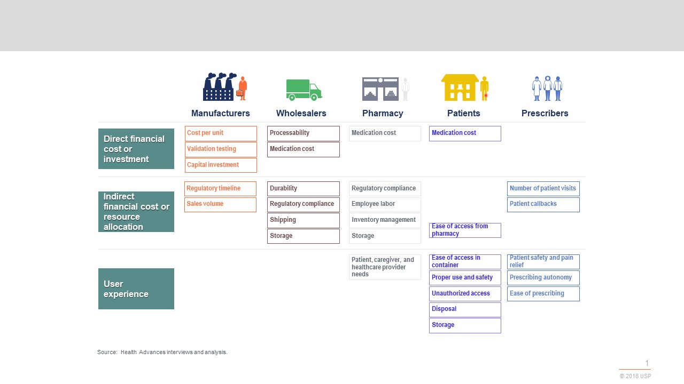

A change to unit-dose packaging likely has the most significant impact on manufacturers, due to the need to shift entire operations and manufacturing lines from bottling to novel unit-dose packaging, like blister packs. If a change to unit-dose packaging is required, manufacturers may need a grace period to implement all changes to their packaging lines and to avoid supply shortages.

Regarding the safe disposal of packaging, the research indicates that the anticipated impact on stakeholders is relatively small; however, pharmacies may resist any changes if they are financially responsible for the safe-disposal mechanism.

We look forward to releasing a full report of our work and potential implications for all stakeholders. We would like to work with the Agency and interested parties to continue to develop conclusions and expand on these findings.

As the Agency is considering innovations in packaging to help address the opioid crisis, we offer our support to FDA as a resource and collaborator to help identify means to achieve development, adoption and implementation of approaches. We are committed to work with the Agency and stakeholders in generating flexible solutions in this effort, to retain opportunities for creativity and innovation in this critical and evolving space.

***

We thank the Agency for the opportunity to comment. For more information, please contact Elizabeth Miller, Pharm.D.; Vice President, U.S. Public Policy and Regulatory Affairs, at [ehm@usp.org](mailto:ehm@usp.org); (240) 221-2064.

Sincerely yours,

Jaap Venema, Ph.D.

Executive Vice President and Chief Science Officer

[jpv@usp.org](mailto:jpv@usp.org)

(301) 230-6318

1. USP is an independent, nonprofit, scientific organization governed by a Convention comprising over 450 leading organizations and institutions in health and science from the public sector; academia; industry; healthcare practitioners; and consumer and patient communities. USP’s longstanding collaboration with regulators and stakeholders has worked continuously to benefit public health through quality medicines.
2. USP also filed comments to Docket No. FDA-2017-N-5608 on the request for comments for “Opioids Policy Steering Committee,” at <https://www.usp.org/sites/default/files/usp/document/about/public-policy/usp-comments-fda-opioid-committee.pdf> (Dec. 21, 2017).
3. See USP Statement of Commitment, ”Responding to the Opioids Crisis through Public Standards,” National Academy of Medicine, 2019, <https://nam.edu/wp-content/uploads/2019/04/USP_Statement_of_Commitment_on_Opioids.pdf>.
4. B.K. Zedler et al. (May 2011), "A pharmacoepidemiologic analysis of the impact of calendar packaging on adherence to self-administered medications for long-term use,” Clinical Therapeutics. 33(5), <https://www.ncbi.nlm.nih.gov/pubmed/21665043>.
5. M. Tenenbein. (June 2005), “Unit-Dose Packaging of Iron Supplements and Reduction of Iron Poisoning in Young Children,”Archives of Pediatric and Adolescent Medicine. 159(6), <https://jamanetwork.com/journals/jamapediatrics/article-abstract/486039>.
6. A.K. Done et al. (October 1971), “Evaluation of Safety Packaging for the Protection of Children,”Pediatrics. 48(4), <https://pediatrics.aappublications.org/content/48/4/613.short>.
7. W. Smith. (May 2018), “Blisters vs. Bottles,” Packaging Strategies. <http://www.keyboxco.com/wp-content/uploads/2018/05/Packaging-Strategies-Blisters-vs.-Bottles-May-2018.pdf>.